McKenzie-Smith, Graham (from Linked In)
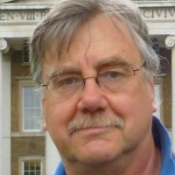

Katoomba High School 1961 – 1965. B Sc (Forestry), M Sc (Forest Management) ANU 1969 – 1970.

Consultant at Grimwade Forestry 1978 – . General manager, Pine Operations Bunnings Forest Products 1981 – 1991. Chief Executive ACT Forests 1991 – 1999.
Semi retired, but still available for interesting projects.
Now researching, writing and publishing widely on the Australian Army in WW2.

Publications: Australia's Forgotten Army, Vol 1, The Ebb & Flow of the Aust Army in WA, 1941 to 1945. Grimwade Publications (1994). Australia's Forgotten Army, Vol 2, Defending the Northern Gateways, NT & Torres St, 1938 to 1945. Grimwade Publications (1996). Defending Fremantle, Bunbury & Albany, 1939 to 1945 Grimwade Publications (2009).

